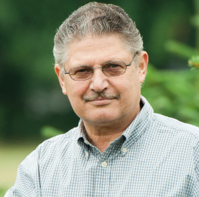
Title: Genomic Pairwise Kinship: A Catalyst for Innovation in Forest and Quantitative Genetics

Yousry A. El-Kassaby
Department of Forest and Conservation Sciences, Faculty of Forestry, The University of British Columbia, 2424 Main Mall, Vancouver, BC V6T 1Z4, Canada (y.el-kassaby@ubc.ca)

Traditional pedigree-based methods in forest tree breeding, while foundational, are hampered by long breeding cycles and incomplete relatedness information. Genomic relationship matrices (G-matrices) derived from SNP data offer a superior alternative by capturing both contemporary and ancestral relatedness. We evaluated a novel GWAS-informed SNP selection strategy for G-matrix construction, prioritizing markers by their contribution to genetic variance rather than solely on statistical significance. This approach was benchmarked against traditional pedigree-based analyses and standard genomic SNP pruning techniques. To assess its broader applicability, we tested the strategy in two species with contrasting genome sizes and genotyping platforms: white spruce (Picea glauca, ~20 Gb, genotyping-by-sequencing) and eucalyptus (Eucalyptus spp., ~640 Mb, high-density SNP array). In white spruce, our GWAS-informed method yielded higher heritability estimates compared to pedigree-based models. Conversely, traditional methods performed better in eucalyptus, likely due to ascertainment bias from the SNP chip. These findings highlight the critical importance of evaluating SNP selection strategies and accounting for marker bias when constructing G-matrices. While GWAS-informed SNP selection demonstrates potential for mitigating missing heritability and improving genomic predictions, its effectiveness is contingent on alignment with species-specific genomic architecture and genotyping methodologies.

Biography
Yousry A. El-Kassaby is a Professor of Forest Genetics at the University of British Columbia (UBC), Canada. He received his PhD in Population and Quantitative Genetics from UBC in 1980. Prior to his academic career, El-Kassaby gained 20 years of experience in the forest industry and a biotechnology startup. His work on tree domestication, gene conservation, biotechnology, and genomics has led to over 400 publications and numerous grants. El-Kassaby is also a Distinguished Professor at Nanjing Forestry University and is the recipient of several prestigious honors, including the IUFRO Scientific Achievement Award (2010), Professor Honoris Causa from the Czech University of Life Sciences Prague (2011), and the Canadian Institute of Forestry Scientific Achievement Award (2017).

Presenting author details
Full Name: Yousry A El-Kassaby
Contact number: + 1(604) 722-7348
Category: Oral presentation

